HOW TO CREATE MARQUEE BASED TESTIMONIALS WITH CUSTOM SECTION:

This guide help you to create custom section in shopify and as well as help you to where to add code and css file in shopify themes files.

When you create an a account on shopify and open your dashboard

Don’t forget to add {% section 'bento-grid' %}

{% section 'testimonials' %} in basetheme or index liquid file code to preview rthe template:

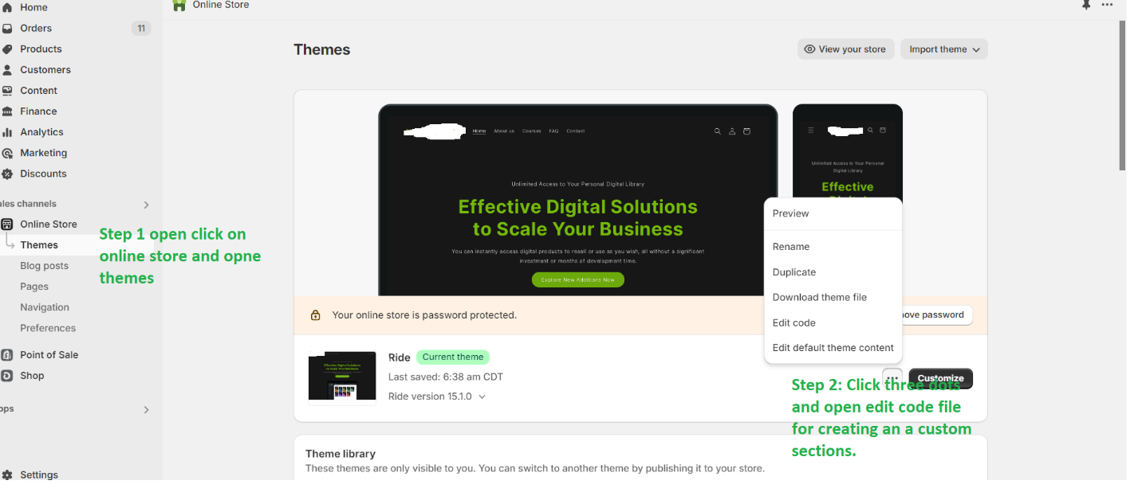

Then

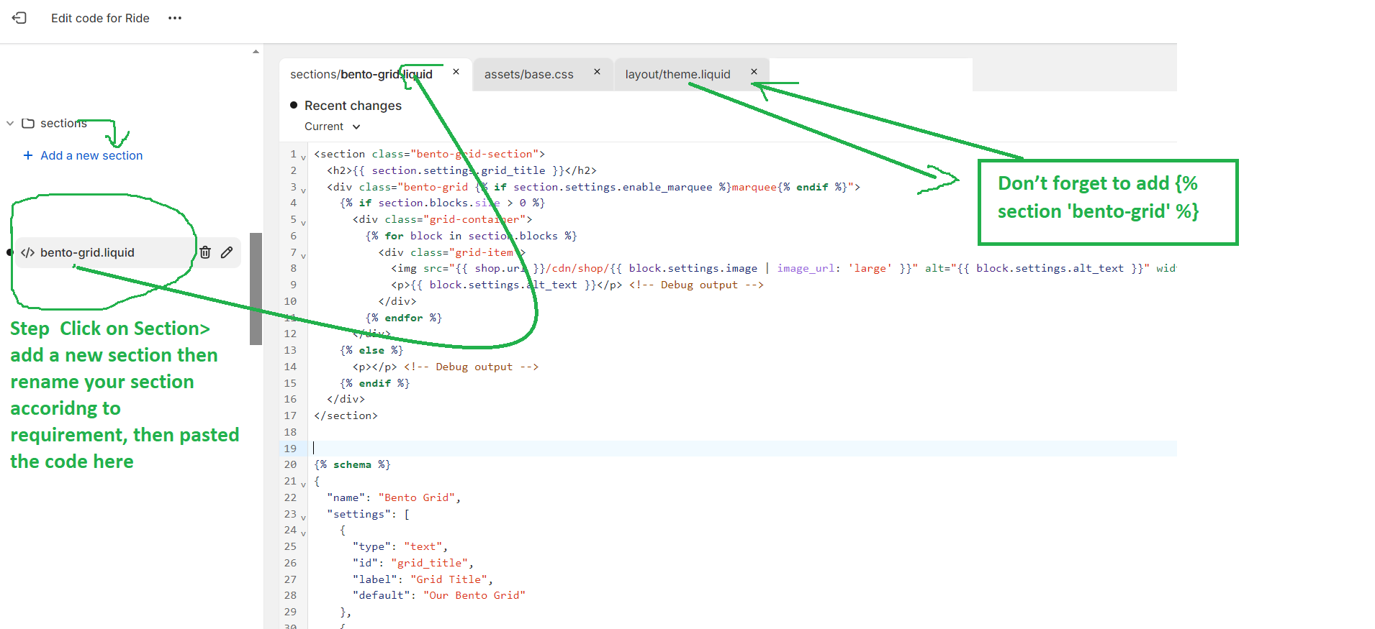

Then

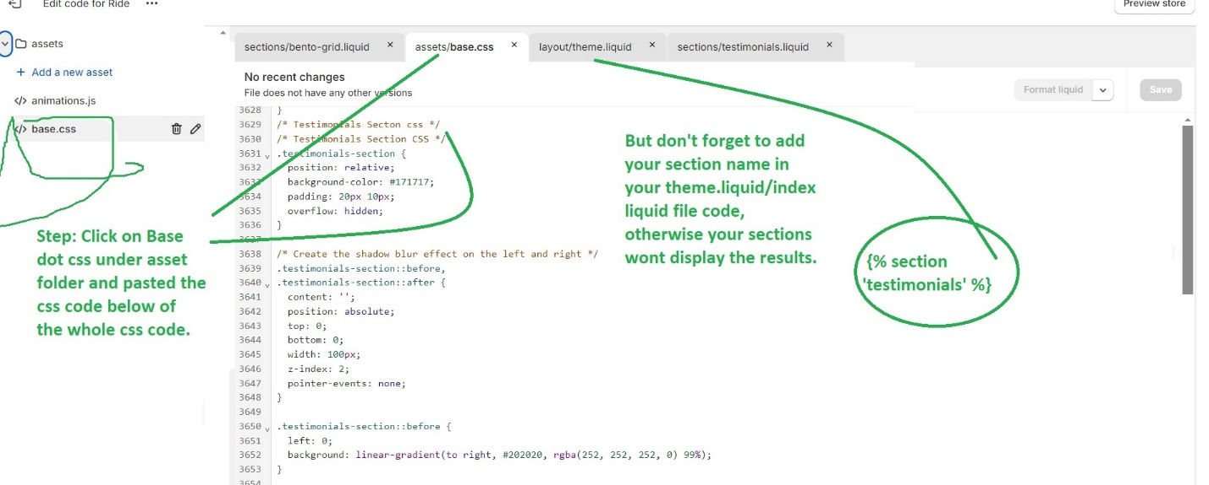



Final result:



